WAKAIWA LAVINIA (RAWINIA) BARRETT - MAORI LAND ENTITLEMENTS

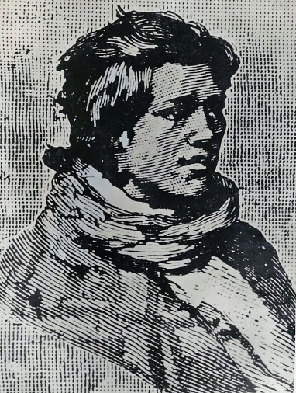 Wakaiwa Lavinia (Rawinia) Barrett; woodcut; unknown provenance; original led by Puke Ariki, New Plymouth Taranaki New Zealand

Caroline and Sarah (Barrett) Honeyfield inherited Maori land from their mother Wakaiwa Lavinia (Rawinia Barrett).

One Maori land Court case provides an interesting insight in to the lineage and family of Wakaiwa Lavinia (Rawinia Barrett), her daughters and their children.

Moturoa F (8 acres on Bayly Road Moturoa Taranaki New Zealand abutting the railway line and reserve land)
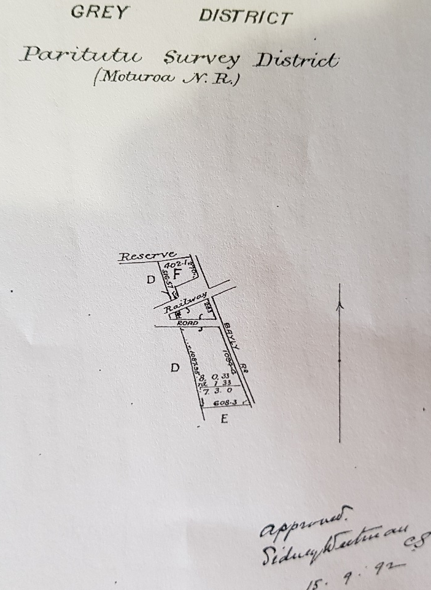

Maori Land Court Documents –
4.3.1887 - Maori Land Court order that a Crown Grant of the land known as Moturoa F be issued to Ihaia Taiwhanga and Hera Waikauri as tenants in common in equal shares
26.11.1902 (7 Taranaki MB 205) – Succession order re interests of Kara Honeyfield in Ngatirahiri Sections No. 3 and 9 - Mr J Gray told the Court she died 3 years ago and left children Barrett Honeyfield (m) William Honeyfield (m) Sarah Honeyfield (f) Charles Honeyfield m); Court order - in favour of Barrett Honeyfield (m) William Honeyfield (m) Sarah Honeyfield (f) Charles Honeyfield m) equally
5.10.1898 (39 Whanganui MB 123) - Succession order re interests of Hera Honeyfield in Ngatirahiri Sections No. 3 and 9 – Richard Honeyfield told the Court Deceased was my mother; she died 27.6.1898. She left - Richard Barrett Honeyfield William John Honeyfield Henry James Honeyfield Ellen Caroline McLean Edmund Charles Honeyfield. Court order – in favour of Richard Barrett Honeyfield William John Honeyfield Henry James Honeyfield Ellen Caroline McLean Edmund Charles Honeyfield equally
12.8.1908 - Maori Land Court order that the interest of Hera Waikauri (alias Herata Waikauri) be transferred to:
Barrett Honeyfield (1/8) William Honeyfield (1/8) Sarah Honeyfield (1/8) Charles Honeyfield (1/8) [the then surviving children of Caroline (Barrett) Honeyfield)
Richard Barrett Honeyfield (1/10) William John Honeyfield (1/10) Henry James Honeyfield (1/10) Ellen Caroline McLean (nee Honeyfield (1/10) and Edmund Charles Honeyfield (1/10) [the then surviving children of Sarah (Barrett) Honeyfield)
27.7.1914 – hearing 27.7.1914 – amending order – that the interest of Hera Waikauri in Moturoa F should go to her grand children Te Kauri Paraone and Kararaina Paraone equally [confirmed that Harata Waikauri (Rawinia Barrett’s sister) and Hera Waikauri were different people; The Honeyfields accepted that Te Kauri Paraone and Kararaina Paraone were the parties entitled to the relevant land through Hera Waikauri]

1908 Maori Land Court No. 172 (Moturoa F) (Rataphihpihi A East)
Applicant: Barrett Honeyfield (representing himself his brothers sisters and cousins) v. Hera Waikauri deceased alias Herata Waikauri
Applicant’s solicitor: Mr D. Hutchen
Testimony at the trial included the following:
Hera Waikauri deceased alias Herata Waikauri – she died in 1887
Hoera Pare Pare (son of Harata Pika) died in 1876; before his mother died

Witness: Jane Maria Phillips (she is related to Barrett Honeyfield; they are descended from the same great great grandfather). She states - Herata Waikauri left no Will; she left no issue; she had a son named Hoera who pre-deceased her and left no issue. Her next of kin are the Honeyfields. She was in Court when succession to the deceased in respect to the interest in the Ratapihipihi land (at Barrett Road) was dealt with but she did not give evidence. Mrs James Honeyfield then gave evidence (her Maori name was Kara or Kararaina; she is dead). She had a sister named Hera, who is also now dead.

Mr D Hutchen – succession orders were made on 26.11.1902 and 5.10.1898 regarding the interests of Kara and Hera Honeyfield in Ngatirahirihiri No. 3 and 9. He wanted to correct the details of their children as follows:
Children of Kara: Barrett Honeyfield (m) William Honeyfield (m) Sarah Honeyfield (f) and Charles Honeyfield
Children of Hera: Richard Barrett Honeyfield (m) William John Honeyfield (m) Henry James Honeyfield (m) Ellen Caroline McLean (nee Honeyfield) (f) and Edmund Charles Honeyfield (m)
He referred the Court to Tara. Vol. 6 p90 – Renata Kauereira there gave evidence - stated that Caroline and Sarah were daughters of Dicky Barrett. Their mother was Rawinia – who was sister of Hoera Pare Pare – latter had three sisters Harata Waikauri, Harata Pikia and Rawinia. Barrett’s two daughters married two brothers named Honeyfield.

Witness: Jane Maria Phillips – stated - Harata Waikauri had a younger sister who was born after she had been taken away by the Waikato. The younger sister was also named Harata, as it was thought that Harata Waikauri had been killed. The eldest sister was Rawinia – who was sometimes called Kara. The younger Harata died without leaving issue. The next of kin to Hoera Pare Pare now living are the Honeyfields – the grandchildren of his sister Rawinia.
I heard that Renata Kauereia is dead but I cannot give his date of death

Mr I H Walker [1908 Maori Land Court case No 172 Moturoa F page 73] – states that Eurera Kipa’s father was Manihera Kipa alias Neha Kipa (Mere’s first husband). In the succession of Hoera Parepare in Section 168 Oakura the widow Miri (Amiria) Ruakere got 1/3, Harata Waikauri got 1/3; the two Mrs Honeyfields (Kara and Hera) got 1/6 each. [Sec Tara Vol 6 pp71 & 90]. Herata Renata mentioned in proceedings [Tara Vol 3 p 275] was the same person as Harata Pikia. She married Renata Kauereia (now deceased).

William John Honeyfield was an Applicant and witness.
He stated that:
I knew Renata Kauereia. He is dead. He died last year [date fixed as August 1907]; left no issue; I do not know that he left a will.
D Hutchens – Renata Kauereia had an absolute interest in the land and Meri Ruakere had a life interest with the remainder to Eruera Kipa. He is the son of Mera Renata (second wife of Renata Kauereia), but not a son of Renata
Mr I H Walker – states that Eurera Kipa’s father was Manihera Kipa alias Neha Kipa (Mere’s first husband). In the succession of Hoera Parepare in Section 168 Oakura the widow Miri (Amiria) Ruakere got 1/3, Harata Waikauri 1/3 the two Mrs Honeyfields (Kara and Hera) 1/6 each. [Sec Tara Vol 6 pp71 & 90] Herata Renata in proceedings [Tara Vol 3 p 275] was the same person as Harata Pikia. She married Renata Kauereia (now deceased)
Court – Defendants right in this land was based on the Will of Hoera Parepare [Tara Vol 3 p299] [Will dated 21.7.1776] [details below]

William John Honeyfield was an Applicant and witness.
I do not know Maori.
I knew Hoera Parepare well. He was an uncle to me or rather great uncle. He was the brother of my grandmother Rawinia [Mr Hutchen noted that the whakapapa was acknowledged in the previous case]
Hoera Pare Pare married Miri (Milly) Ruakare. [Amiria Miri Ruakere Miri Hoera]
They had no children
I only heard recently that they had adopted Eruera Kipa (Skipper).
This may be why Hoera Pare Pare made a will in favour of Miri and Eruera
I never heard my mother or my aunt Mrs Kara Honeyfield ever say anything about that adoption
Hoera Pare Pare died at Moturoa, near New Plymouth
I could not say who had to do with making arrangements re his burial, or who defrayed expenses - I know my aunt “E Kara” (Mrs Kara Honeyfield) had the most to do with it – I cannot give date of his death – nor can I say how many years ago it took place – I think that it was not more than 12 months after the Govt bought the Prison reserve – I do not say positively whether my aunt P. [paid] the principal share of expenses in connection with the burial, but she appeared to me to be taking a leading part in matters as a relation to the deceased – I was only a boy at the time – I cannot say how old I then was – I was not a youth – I was only a boy – I am now 52 years old.
[Comment in Court next day 13.10.1908. W J Honeyfield cannot have been correct as he is now 52 years old; Hoera Pare Pare made his will in 1876. Mr Honeyfield must have been 20 years old when Hoera died]
Mr Hutchen stated – Mr Richd B Honeyfield, now in Court, has informed him that Hoera Pare Pare died in 1876 – he (R B H) is now 55 yrs old

Witness Amiria Kihi page 80 – I knew Hoera Parepare. His wife’s name was Miri (Miri Hoera), now Miri Ruakere. No child was born to them. The only child they had that I know of was Eruera te Puke -ki-Mahurangi. He is the person now known as Eruera Kipa. Hoera Parepare ‘tap’d the name Eruera te Puke -ki-Mahurangi. He was the son of Neha Kipa (aka Te Manihera). His mother’s name was Mere te Kiri. Te Manihera and Hoera Parepare were related. Their mothers were elder (Heni Hineone (f)) and younger sisters (Kara Kuramaiitera (f)). Heni Hineone was the mother of Te Manihera Kipa (m) and Kara Kuramaiitera was the mother of Hoera Parepare (m). Eruera te Puke -ki-Mahurangi is the name of Kara Kuramaiitera’s husband.

Witness (Eruera Kipa) – aka Eruera Te Puke – Ki- -Mahurangi [Rawinia’s fathers name; given to him by Hoera Pare Pare after he was ‘adopted’]. Europeans call him Eruera Kipa. His father’s name is Kipa. He is also known as Huirua. He was 16 or 17 when Hoera died and is 49 yrs old now [Hoera died in 1876] He lived with Hoera and Miri.
He knew Hoera Parepare. His wife’s name was Miri Tapaki. She was known as Amiria Hoera Parepare and also Miri Ruakare. He was taken by Hoera and Miri as ‘tamaiti whangai’ (adopted).
Hoera Pare Pare died at Te Ratapihipihi. I saw the half-castes – the children of Kara and Hera [Honeyfield] – about there at that time – They attended the ‘uhunga’ – None of them had gone there to take care (tiaki) of Hoera while he was ill – After Hoera’s death, I and his widow cont’d to live at the kainga – at Te Ratapihipihi. Hoera left a ‘tohu’ to me and his widow. That ‘tohu’ was a Will – It left in favour of myself and his widow, Miri Ruakere married Ruakere after Hoera Parepare’s death]– and also in favor of Renata Kauereia – [To Court] That Will is in the hands of the Public Trustee. I was named after Hoera’s father [note: actually grandfather].
He derives income from land (Moturoa A and at Ratapihipihi) under Hoera’s Will. Miri Ruakere has a life interest under the Will. He is entitled to the remainder.

His Whakapapa
Tautara (m) = Maheuheu

Hineone Kuramaiterra [Kura Mai te Ra]

Neha Kipa Hoera Parepare

Eruera Kipa
(aka Eruera Te Puke
– Ki- -Mahurangi - named after
Hoera’s father)

He doesn’t know how he is connected to the Honeyfields
Hoera’s Will includes Renata Kauereia.
He only seeks to claim what is in Hoera’s Will
Mere Renata (aka Mere te Kiri) married Renata Kauereia after his father Neha Kipa died
[Note: Claims under adoption were not introduced in Taranaki NZ until 1894]
He has heard that Kuramaitera had other children besides Hoera Parepare but he doesn’t know any details of them

Witness – Hamarama Watere Taungatara (m)
He knew Hoera Parepare his wife Miri and adopted son Eruera Kipa
Miri married Ruakere after Hoera Parepare died
I knew of Hoera Parepare and two sisters, both of whom were named Harata – one being Harata Waikauri – I do not know the second name of the other Harata. She was the Harata who married Renata Kauereira
Harata Waikauri died at Auckland
I do not dispute that Hoera Parepare had three sisters. I only knew two. I never saw Rawinia
I did hear of another sister of Hoera Parepare whose name was Rawinia. I heard of Rawinia as being ‘tuahine tuturu’ to Hoera Parepare not a ‘tuahine turanga’
In the year of his death Hoera Parepare received a large sum of money for his share of sale of land at Moturoa to the Govt for a prison. Around that time he started to drink heavily
He understood that only Hoera [Parepare] had adopted [Eruera Kipa]
Sisters of Hoera Parepare - one of their living relatives is [in Court] [Richard Barrett Honeyfield]
I am not acquainted with Kara’s children but I know some of Hera’s children, including [R B Honeyfield] . I became acquainted with them at Moturoa. I knew them in bygone years - when we were young people. We were living together at the same kainga in those days - I can only speak of those I knew.
Eruera Kipa or Te Puke-ki-Mahurangi - was also living there - at Moturoa. The man Honeyfield [R B Honeyfield] then lived at Te Awapirau about 200 yards from the old pa at Moturoa. I say that Te Puke -ki-Mahirangi was Hoera’s ‘tamaiti’ whangai’
Hutcheon closes his case
Mr Damon opens his case
Eruera Kipa and the Applicants claim that the defendant (Renata Kauereira dec’d) derived his right in this land under a will made by Hoera Parepare.
Eruera Kipa claims that this interest should revert to him as ‘tamaitu whangai’ of Hoera Parepare who made a Will in favour of the deceased.
The Honeyfields claim as next of kin to Hoera Parepare that as he died without issue this interest should revert to them
Damon for Wi Ropata and his whanau claim that they are the next of kin of the deceased Renata Kauereia because:
1. As this land was the subject of a will the ‘take Maori’ became extinguished and it would be proper for it to be dealt with in accordance with European law as though it were European land in accordance with the law of NZ and not in accordance with ‘tikanga Maori’. So his clients are successors (Kia riwhi) (section 2 of the 1894 Act)
Hutchens started - this land was not the subject of an English title when the will was made. Renata did not come in to the title by his own right but under the Will of Hoera Parepare - by his Will Hoera made himself foster father of Renata. The Native custom, where there is no direct descendants, is to go back up the line through which the interest in the land was acquired. In this case the interest was not derived by the deceased through ancestral line either paternal or maternal.
[Court - after 1901 adoption required to be registered]
Case closed decision reserved
Court wanted to see will of Hoera Parepare (produced 3.6.1887) in the case re Ratapihipihi Reserve [Tara Vol 3 p 274]and referred to in [Tara Vol 3 p 299]

Case No. 569 Ratapihipihi A East; date 14.10.1908 (recorded from page 101)

Applicant Barrett Honeyfield v same- by his solicitor D Hutchen

Hutchen - this is exactly the same position as the last case. He asked for order in favour of his clients.

Hauikamu te Hiko - he claimed on behalf of Eruera Kipa as ‘tamaiti whangai’ as the last case, based on the will,of Hoera Parepare..

Mr Damon - he claimed on behalf of Wi Ropata and others, as next of kin to the deceased as in the last case

Decision reserved

Court order in this case - that the descendants of Te Ranagiauahi are the persons entitled to succeed to this interest of Renata Kauereira deceased in Ngatirahiri No 3 and 9. Making of formal order held over to see if parties can agree a division of amongst themselves

19.10.1908. No 173 Moturoa A case resumed and No 569 Ratapihipihi A East re succession to Renata Kaueriera deceased

Hoera Parepare made a Will in 1876 – details of which are set out at page 126 of Maori Land Court case No 173 re: Moturoa A (1908) and also relevant to No. 569 re: Ratapihipihi A East and set out below:

I Hoera Parepare of Ratapihipihi Taranaki, an aboriginal Native declare this to be my last Will.
I give all land at Ratapihipihi and Moturoa being parts of Reserves numbered 5 and 1 -
to my wife Miri Hoera and my sister Harata Renata to share equally between them after my death - At the death of Miri Hoera her share is to revert to Eruera Kipa or his heirs.- At the death of Harata her share is to go to Renata Kauereira or his heirs - and I appoint Charles Brown Civil Commissioner Taranaki as my Executor and should he decline to act I appoint Wilfred Rennell Licensed Interpreter of Taranaki as my Executor.
Hoera Parepare by his x Mark
Signed by the said Hoera Parepare this 21st day of July 1876 as his last Will, in the presence of us, present at the same time, and who, at his request, and in his sight and presence, and presence of each other, have hereunto subscribed our names as witnesses attesting the same.
Witnesses - Piripi Ngahuka, a Maori of Ratapihipihi
- Koani (Hoani?) Paora
He tangata Maori au no Mangaone

19.10.1908
No 173 Moturoa A
No 569 Ratapihipihi A East
Court found- by his Will Hoera Parepare devised his lands at Moturoa and Ratapihipihi in two equal parts. One moiety was devised to his wife Miri Hoera, with reversion at her death to Eruera Kipa or his heirs. The other moiety was devised to his sister Harata Renata, with reversion at her death to Renata Kauereira or his heirs.
Held - the reversion to Renata Kauereira or his heirs became absolute after the death of Harata. It was not limited to ‘heirs of the body’ and therefore so long as any heirs in the broad sense of the term can be found, they must be deemed to be the rightful successors.

This work has been compiled by Anne Hodgson for the celebration of the 150th year of Honeyfield ownership of the farm land at Tataraimaka Taranaki New Zealand on 27 January 2019.

